1. Login Request and Response

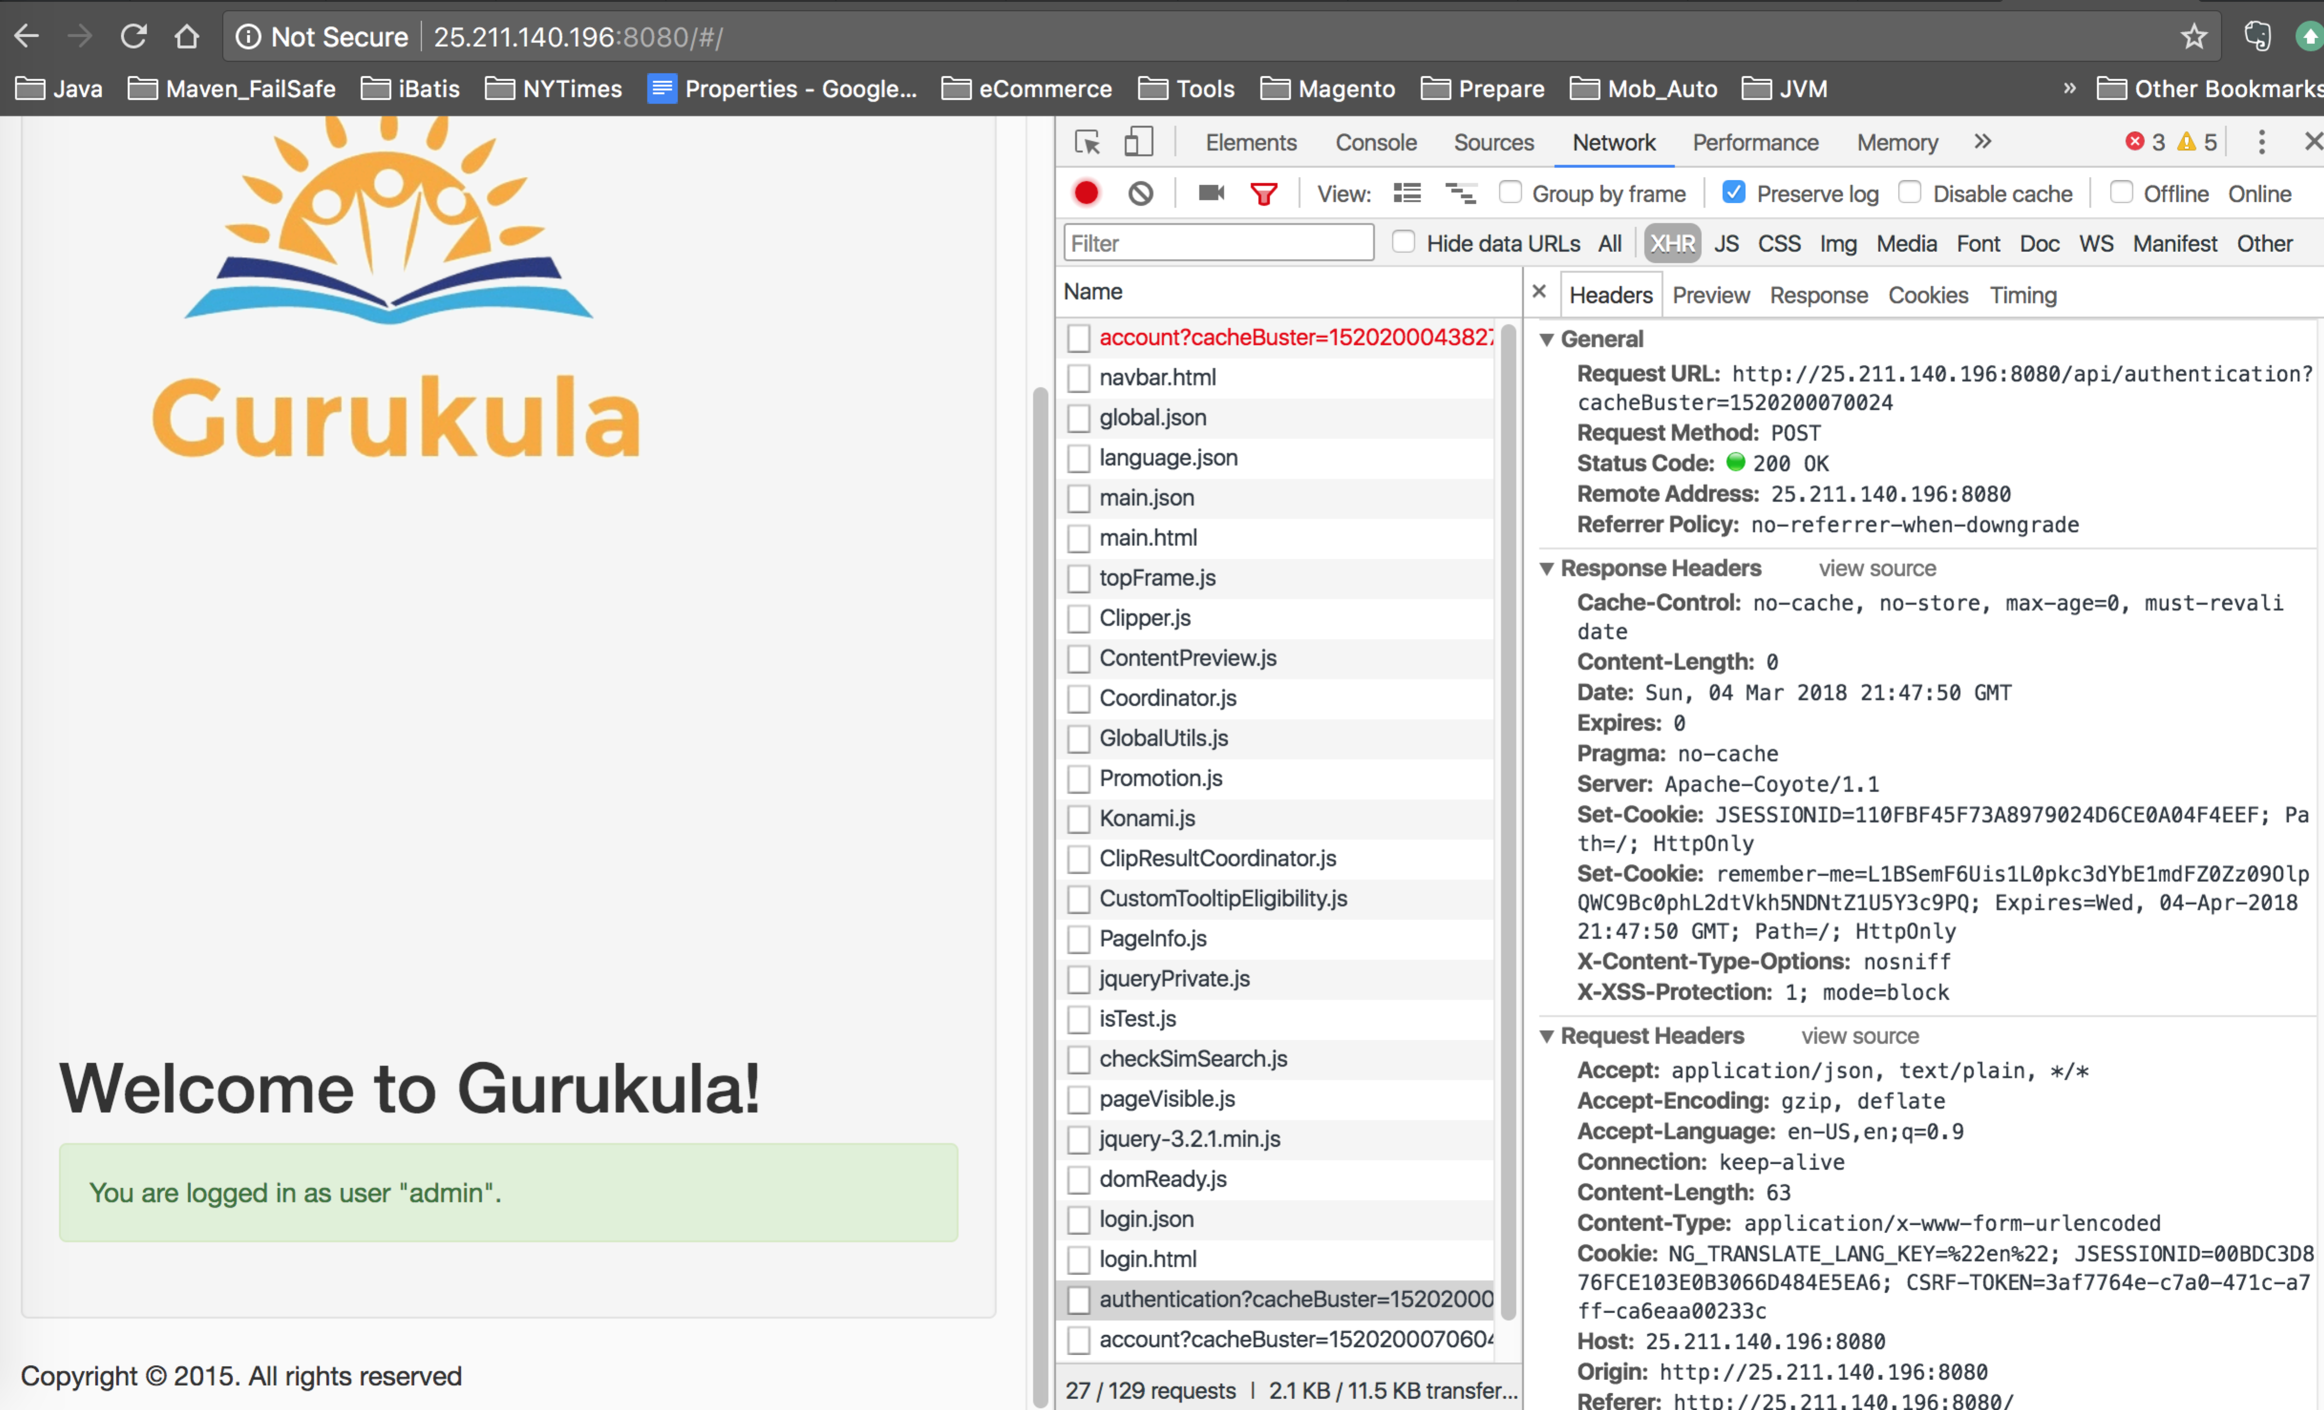

1. Reset Your Password Request and Response

